Mediline is one of the North West of England’s largest and highest quality specialist provider for people with learning disabilities, autism and other complex care needs and are proud of our sector leading outcomes and reputation for delivering high quality care and support. We take our responsibilities as an employer very seriously and focus on ensuring quality, diversity, equality and inclusion are embedded throughout everything that we do. The data in the Gender Pay report for the period 2022-2023 shows that for the overwhelming majority of our employees, there is no or a very minimal, gender pay gap.

All companies that employ more than 250 employees are required to report their gender pay gap under the Equality Act 2010 (Gender Pay Gap Information) Regulations 2017.

This involves carrying out six calculations that show the difference between the average earnings of men and women in our organisation; it does not involve publishing information about individual employees.

The following report has been produced in compliance with the regulations and the results are based upon the snapshot date of 5th April 2022. The results have been published on the Government website where they can be found by searching for Mediline Supported Living Ltd.

Gender Pay Gap Results

In analysing the data, we recognise more females in the most senior levels of our organisation accounts for the gap that does exist in the upper quartile data and in our mean bonus gap; however we are encouraged to have seen performance sustained in other areas.

|  |  |
| --- | --- |
| Mean pay gap | -6% |

|  |  |
| --- | --- |
| Median pay gap | 0% |

Bonuses account for less than 1% of our total wage bill and there is no median gap (0%) in our bonus pay and our mean bonus gap stands at -113%. The proportion of females receiving a bonus was 20% compared to 16% of males.

The proportion of men and women by quartile band:

|  |  |  |  |  |
| --- | --- | --- | --- | --- |
|  | Lower Quartile | Lower Middle Quartile | Upper Middle quartile | Upper  quartile |
| Male | 34% | 34% | 34% | 25% |
| Female | 66% | 66% | 66% | 75% |

By means of explaining what these figures mean

* A positive figure shows that the female employees have lower pay or bonuses than the male employees;
* A negative figure therefore implies that male employees have lower pay or bonuses than female employees;
* A percentage of zero shows no gap between the pay or bonuses of male and female employees

If you have any questions about gender pay gap reporting, please speak to your manager in the first instance.

I confirm that the data is accurate as of the snap shot date of the 5th April 2022.

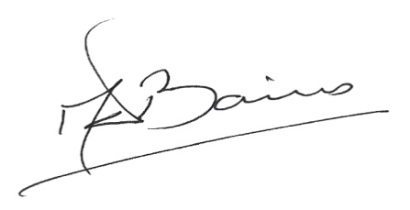

Michael Baines

Director and Chief Executive